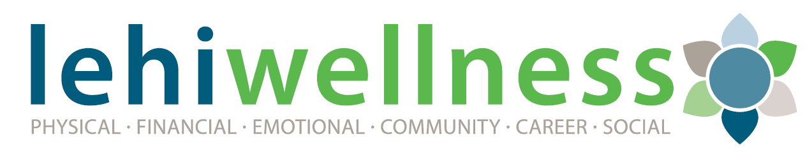
Purpose of the Lehi City Wellness Program
The purpose of the City’s 2020-2021 wellness program is to preserve high quality benefits and support employees to optimize their performance by achieving their best health. Nationally and locally, people are affected more than ever by the additional stress, poor life style habits, and just being too busy to focus on taking care of their health. Employees who are engaged in healthy lifestyle activities generally deal with stress better, are more focused at work, and tend to be healthier. Given the research and the desire to improve the health of our employees, we are excited to enhance our wellness program.
Reaching healthy goals is a very individual process and this program allows everyone to succeed. Employees who enroll in the wellness program will not only benefit from participating but may also receive a premium advantage on their health insurance and earn rebates offered through PEHP, our medical insurance carrier.
To assist our employees with their personal health, we have adopted the following six aspects of well-being from PEHP.
Wellness Aspects
CAREER - Creating a healthy and supportive work environment. Obtaining personal fulfillment from our jobs or our chosen career fields, while maintaining balance in our lives. Having opportunities to learn and grow.
COMMUNITY - The sense of belonging to, and engagement with those around us in the areas where we live and work. Giving back to society. The ability and responsibility to make a personal positive impact on the quality of our environment in our homes or communities.
EMOTIONAL - Understanding ourselves and our feelings while being able to cope with the challenges of life in a healthy manner. The psychological and emotional outlook that people hold concerning their lives.
FINANCIAL - Managing your income and economic life in an effective way for your personal needs. Having a balance of the physical, mental, and spiritual aspects in our dealings with money. Understanding limits on our incomes and living within our means by keeping expenses in check.
PHYSICAL - Maintaining a healthy quality of life that allows enough physical and mental energy to be productive throughout the day. Recognizing that our behaviors, good or bad, can have a significant impact on our overall health and wellness.
SOCIAL - Building strong, healthy relationships with family, friends, and coworkers. Developing the ability to relate to and connect with other people in the world.

Annual Required Points
- Complete the PEHP biometric screening (1 point) offered on site each fall.
- Complete the online PEHP (HRA) Health Risk Assessment (1 point).
- Complete up to 10 additional wellness points by April 30, 2021 under Wellness Aspects.

Additional Point Incentives
There are additional point incentives for employees who achieve more than 12 total wellness points between May 1st, 2020 and April 30, 2021. Additional points can be used towards the following items and will be calculated after completion for points earned as of May 1, 2020.
10 additional points (22) = choice of $50 AwardCo points, $50 HSA contribution, or $50 applied to the employees paycheck
20 additional points (32) = 5 (five) vacation hours or another $50 (total of $100) AwardCo points, HSA account or paycheck

For purposes of this summary, there is a shortened example of available points for your understanding.

WELLNESS ASPECTS
10 points are required in the areas below in addition to the points for the Health Risk Assessment (1 point) and the Biometric Screening (1 point). All items have the value of 1 point unless indicated by an asterisk.
PHYSICAL

- Annual Flu Shot
- Dental or Vision Exam
- Aerobic Exercise 2 month log (Must exercise a minimum of 30 minutes, 3x/week or equivalent)
- Take a hike of 5+ miles roundtrip with an elevation change of at least 500 ft
- 5k Walk/Run Race
- Attend a Dietitian onsite workshop
- Nutrition/Weight Management wellness challenge

FINANCIAL
- Attend a financial planning workshop (min 1 hour)
- Increase personal retirement savings, URS or ICMA, by 3% or more
- Participate in a financial wellness challenge
- Read a book about improving your finances

EMOTIONAL

- Attend an EAP onsite workshop
- Contact an EAP counselor for a free, brief counseling session
- Research what mental health resources are available in your community
- Read a book about mental/emotional health

COMMUNITY
- Research city trails and take three (3) 1 mile walks or runs on these trails
- Participate in a Beautify Lehi project or a separate community service project (min 1 hour)
- Attend Planning Commission or a City Council Meeting outside normal work hours (min 1 hour)
- Attend/volunteer at the City Expo, Lehi Round-Up Week, Family Week, or the City Health Fair (min 1 hour)

CAREER
- Attend employee Health Fair (September)
- Complete the Lehi City CPR/First Aid class or a required department safety class
- Attend an EAP workshop or participate in a webinar that is related to your job (communication, managing time, problem solving, conflict management, etc.)
- Read a book related to your career

SOCIAL

- Serve on an employee committee
- Attend another department staff meeting
- Attend an annual city employee gathering (Mayor’s BBQ/Holiday Event)
- Find and attend a community club activity (book club, biking club, hiking club, etc.)

