Energy Conservation

During the summer months, Lehi City residents consume huge amounts of energy. The Lehi City Environmental Sustainability Committee wants to challenge residents to conservation energy this summer. Energy conservation is one of the words you are hearing more and more. Unfortunately, a lot of the places you will hear it will be in ads marketing products or lifestyle habits that may have nothing to do with actual energy conservation. The Environmental Sustainability Committee want residents to know what real energy conservation techniques are, and how they can utilize these techniques to help conserve our vital resources, while saving money in the process.
Understanding Energy conservation
Energy conservation is not about making limited resource’s last as long as they can, that would mean that you are doing nothing more than prolonging a crisis until you finally run out of energy resources all together. Energy conservation is the process of reducing demand on a limited supply while enabling that supply to begin to rebuild itself.
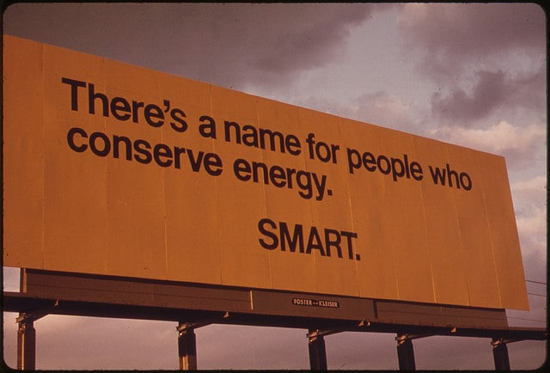
Why is it important?
Without energy conservation, the world will deplete its natural resources. Most people don’t see that as an issue because it will take many decades to happen and they foresee that by the time the natural resource is gone there will be an alternative.
The Goal
The goal for energy conservation is to reduce demand, protect and replenish supplies and develop, and use alternative energy sources. In an effort to promote energy conservation, the Lehi City Environmental Sustainability Committee would like to suggest Practical Methods for Energy Conservation.

Below are 10 energy conservation techniques that can help Lehi City residents reduce their overall energy consumption and save money.
- Install LED Lights: Try replacing incandescent bulbs in your home with LED bulbs. LED bulbs cost more upfront but last 12 times longer than regular incandescent bulbs. LED bulbs will not only save energy but over time you end up saving money.
- Lower the Room Temperature: Even a slight decrease in room temperature by a degree or two, can result in big energy savings. The more the difference between indoor and outdoor temperature, the more energy it consumes to maintain room temperature. The best way to maintain this goal is to buy a programmable thermostat.

- Fix Air Leaks: Proper insulation will fix air leaks that could be costing you. During winter months, you could be letting out a lot of heat if you do not have proper insulation. You can fix those leaks yourself or call an energy expert to do it for you.

- Use Maximum Daylight: Turn off lights during the day and use daylight as much as possible. This will reduce the burden on the local power grid and save you money.

- Get an Energy Audit Done: Getting an energy audit done by hiring an energy audit expert for your home is an energy conservation technique that can help you conserve energy and save money every month. A home energy audit helps you identify areas in your home where energy is lost. The audit offers suggestions and tips to implement, saving energy used, and money spent.

- Use Energy Efficient Appliances: When planning to buy electrical appliances, consider appliances with an Energy Star rating. Energy efficient appliances with Energy Star ratings consume less energy and save you money. The Energy Star rated appliances may cost more money up front, but they will operate more efficiently and cost less over time.

- Drive Less, Walk/Bike More: Another energy conservation technique is to drive less and walk or bike more. This will not only reduce your carbon footprint but it will also keep you healthy.

- Switch Off Appliances when Not in Use: Electrical appliances like computers, printers, etc. continue to use electricity even when not in use. Switch them off if you don’t need them and save energy and money.

- Plant Shady Landscaping: Shady landscaping outside your home will protect it from intense heat during hot and sunny days of summer, and cold, chilly winds during the winter season. This will eventually turn to big savings.

- Install Energy Efficient Windows: Some of the older windows installed in our homes aren’t energy efficient. Double pane windows and other vinyl frames are much better than single pane windows. Choosing correct blinds can also save on your power bills.

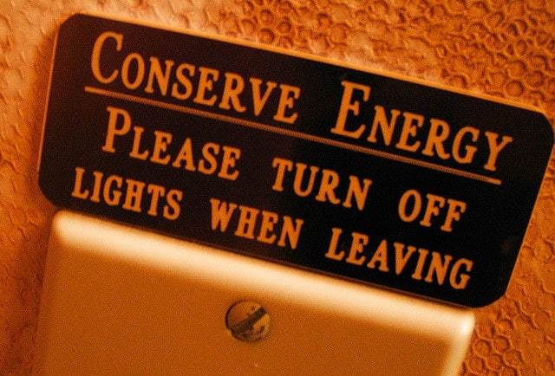

Small steps enable huge changes when multiplied by everyone doing a little bit to conserve. Conserving energy creates a “Win Win” scenario for all Lehi City residents; providing a sustainable future for our children while saving money.

