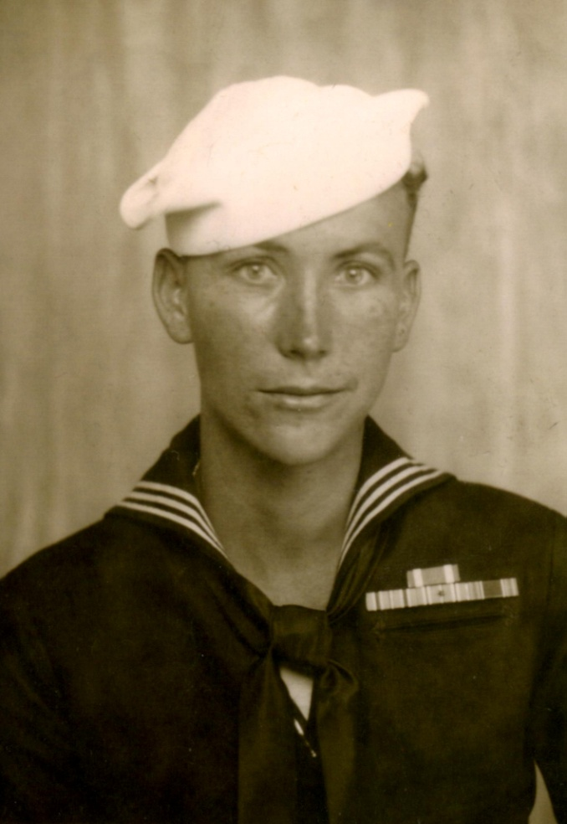
Vivian Carter
as interviewed by Judy Hansen

Vivian Carter was born at home in Lehi, Utah. The home was located up the creek in the area known as Carterville. He was born to Ray and Irene Forbes Carter on March 2, 1926. He had three sisters and one brother; Katherine Ann (Kay) who married Roland (Rally) Dean, Irene Lucille who married a man from Emery County, Doris who died as a little girl in a really cold winter, and James (Jim) Carter.
They were pretty isolated living up in the creek, the only people that lived up there were his dad, his Grandpa Carter, his Uncle Darrell and Uncle Josie (Josiah). They came up and bought the farm off Jack Evans and Doc Watson who couldn’t make the payments on the farm because times were hard in 1918. Once Vivian rode his horse down to 300 west so he could go to scouts. He tied the horse up by the train tracks. That old horse, being up in the creek had never seen a train before. One came along and spooked that horse so bad that he ran away and left Vivian there. Vivian had to walk ½ way home before he was able to catch the horse.
Vivian went to school in Lehi. The Carter children had to walk down to where Bernell Bateman drove a wooden school bus to pick them up. It was an old truck and he built a wooden frame on it and put in some seats. He attended elementary, Jr. High, and High Schools in Lehi down on Center Street. When he was in High School he played Trombone in the marching band. Lehi had one of the best bands in Utah County. Abe Anderson taught band until Mr. Shaw moved in and then he was the band instructor.
His dad played in the Carter Orchestra and Vivian played in the band for his dad while he was going to school. He didn’t get home some nights until 1:00 in the morning, only to get up early in the morning to milk the cows (they had seventeen), and then rush down to school for band. Vivian never had time to get into trouble like the kids do today.
The Carter’s were separating the milk and selling the cream to the Salt Lake Creamery and feeding the milk to the pigs. When the war started they had to have milk to feed the soldiers so someone from the government went to the Carters and asked them to start shipping grade A milk. His dad Ray and Uncle Darrell told them they weren’t equipped to ship A grade milk. They said that didn’t matter, they needed the milk. Ray and Darrell told them they didn’t have coolers to cool the milk but they were told to just get a wash tub and run water in it. So that’s what they did. Well, after they started shipping milk they had to have a milking machine. The first night they put the milkers on the cows there was horse manure all over the barn. The cows didn’t like that. This was after Pearl Harbor day so it had to be in 1941 or 42.
Vivian had a girl in high school, Juanita Fotheringham and he thought they would get married someday but this never happened. He was going to enlist in the Army but his dad talked him out of it. His father told him the war would be over before too long and told him he needed to come back home and help him. There were a lot of sugar beets planted and his father needed his help to harvest the beets to sell to the Lehi Sugar Mill. They also grew alfalfa and grain. After Vivian graduated High School in 1944 he went and enlisted in the service anyway. He went up to Fort Douglas in Salt Lake on the old Interurban train that ran through town. That was the last time he ever rode that thing. The Interurban use to go out through the Jordan narrows to get to Salt Lake and it would almost jump the track every time.
When he got to Fort Douglas they interviewed everyone. Vivian told the man that he wanted to get in the Navy. The man said, ‘You’re in the Navy.’ Then the kid next to him told the man he also wanted to be in the Navy but he was told, “You’re in the Army.” Vivian thought he was going in the Navy. He came home for a couple days and then him and LaVar Bateman had to go back up to the post office building in Salt Lake. When they got to Salt Lake the second time they had Officers from the Army, Navy, and Marines. All the guys were sitting lined up in the hall and someone came in and said, “We need volunteers for the Marine Corps.” They counted off several men, LaVar Bateman was the last one and took them away – they were in the Marine Corp. They counted off more men and took them into the Navy. Vivian just got out of High School but now he was in the Navy.
When you join the service you are not yourself anymore, you are government property. When you raise your hand to take the oath you are part of the U S Government.
They sent Vivian the U. S. Naval Training Station in Farragut, Idaho. Eleanor Roosevelt picked the place for this training station. He was there for three months. Then they sent him to California. He was at Camp Parks at the Shoemaker Navy Training and Distribution Center.
He got down there and thought he was solid in the Navy but they called them all in and sit them down in a warehouse and told them they were being called to the United States Seabees. This is what Vivian called the ‘can do boys.’ They built the road to Japan. The Seabee’s were the U.S. Navy’s Construction Battalion who built miles of roadway and airstrips. He ran jackhammers and dug coral up on the islands to build buildings (that coral was tough). Everyone just done what they were told. Everybody that was in the camp was strictly Seabees. They were a working outfit but Vivian never complained. He was in California for about a month while they were trying to find somewhere to send them.
They put Vivian on a ship, the USS Fairland. It wasn’t a big war ship. It was screwed together with the labor of women in California. It did have guns on it. They took him down to Pearl Harbor, right next to where the USS Arizona was sunk. They wouldn’t let anyone off the ship. Vivian was able to get on a garbage detail so he was allowed to carry the garbage cans off the ship onto the shore. After being there for only a few days, he left Pearl Harbor for Guam. The USS Fairland had to have an escort the rest of the way. Once he got to Guam they took him off the ship and that was the last time he saw that “hunk of junk!”
He helped build the airfields for the B-29’s in Guam. They would load the B-29’s down so heavy with bombs that when the plane would go down the runway getting ready to take off they would waddle like a duck. Some of them couldn’t take off. There was one plane they called ‘no abortion’ because it was able to take off and never aborted any flights. The ones that were too loaded ended up aborting the flight and had to pull off to the side.
Vivian did a lot of work over there. He was on a cement detail, mixing cement to build buildings or other things they needed cement for.
One crew tried to get Vivian to go with them on a bombing crew but the only way he would be able to go was if he signed his life insurance away so if he got killed his parents wouldn’t get any money. It was not his regular assigned duty. Going with the bomb crew would have been doing his own thing and the Navy would not take responsibility because it was not the government ordering him to go.
Vivian had heard there was a LDS church service so he had to walk about 5 or 6 miles to get there. When he got there he found LaVar Bateman, Lynn Gray, and Don Devey, buddies from home. Don Devey from Alpine was in the Marines stationed in Guam and a good buddy to Vivian. It wasn’t much of a church. It was in a Quonset hut.
Vivian was in Guam during the battle of Iwo Jima. There was so many guys that got killed evading that island. The ambulances would come into Guam where there was a big army hospital and blood would run out of the back of them. Guam was a very bloody island at that time.
Most of the hard fighting was over with by the time Vivian got there. Once he fell in a fox hole over there and inside the fox hole was a shell box marked Salt Lake City, Utah which came from the Remington Arms Company plant in Salt Lake. He got so home-sick he got out of the fox hole and went back to work where he was headed to in the first place.
There were a lot of fun times over there but some of it was kind of scary. When he got to Guam they took the guns off them and he asked, “What are we going to do to defend ourselves?” He was told, “You got a knife haven’t you.” It was the marine’s position to guard them.
One time they sent Vivian and some others down in a cave that the Japanese had dug and when he they got in there it was dark, there were no lights they only had candles and matches. Something told Vivian in his head to get the heck out of there so he told his buddy they better go. They were able to get some shell souvenirs and stuff on the way out. They stumbled upon a dead Japanese soldier so Vivian cut one of his ribs out. He was going to send it home to his dad. He took it back to the barracks and buried it in the sand so the ants would eat the meat off. Later he started looking at it and remembered what they told him back home in Seminary during High School. He decided he was going to leave the rib right there where it was at. He never brought it home and he never tried to kill anybody.
The next day or two some guys went down in that same cave and got killed. There were some Japanese in there and they were not going to give up that cave.
On one crew he was unloading trucks that was coming up the harbor in Guam. On the shift he was working, they would feed him at night about 1:00 in the morning. He went down to the mess hall to eat and there was a Japanese soldier in the line. The Japanese were starving and would do anything to get food. Vivian got in line to go into eat and some of the guys ahead of him spotted this Japanese dressed in American soldier clothes. When the Jap figure out that he had been spotted he blew himself up with a hand-grenade. It took ½ of the mess hall. It wasn’t much of a mess hall. It just had a canvas top with a screen around it. That was an experience for him.
Toward the end of the war they sent new Seabees in from back east right from boot camp. These guys had guns who liked to shoot. They shot the heck out of the drag lines in the crane and blew out windows. The closest time Vivian came to getting killed was when he went out one night and was coming back to his Quonset hut. A bunch of those new Seabees where scared to death and one of them grabbed Vivian and put a gun in the middle of his back. Vivian told the guy to get that gun away from him or he would take that gun off him and shoot him with it. It was one of his own guys. The new ones were scared to death over there.
The toilets were six holers that they filled with lime to kill the smell. They didn’t use a toilet very long before they had to move them.
One night Vivian walked down the island where Don Devey was stationed and they were having supper. Vivian didn’t have any way to cut his hair. His hair was quite long. Don said it would be fun to trick the marines. Don went and got a nurses uniform and put it on Vivian. Don fixed Vivian’s hair all up, put him in some boobs, and sent him to the chow line. The marines were fighting over who was going to get his tray for him. Vivian thought, “My gosh, these guys are going to kill me if they find out.” Don stood there and laughed. When they found out he wasn’t a women Vivian left the camp in a hurry. Ol’ Don he was always full of tricks but a pretty good guy. Don was always good to Vivian and was a cousin to the woman that Vivian eventually married.
Vivian believes that most of his unit made it back home. He doesn’t remember any getting killed. They moved a lot of them. Some of them couldn’t take it out there. They sent one kid back home for a while but told him he would have to come back. About the time Vivian was ready to leave, here come the kid back who had to stay there until his time was up.
Vivian had a lot of money from the war. He worked on the late shift and when he got back all the other guys was playing cards on his bed. He decided if they were going to stay there all night he would start playing with them. He got to be quite the poker player and made a lot of money. He sent it home to his mother. The guys would get mad because he was sending the money home instead of losing it back to them. He never played cards before he went in the Navy.
It wasn’t always fun and games over there. Guam was in America’s possession and the Japanese took it over. American had to fight to get it back.
They didn’t have any lights to land those B-29’s. All they had were little oil pots that they use to use on the side of the highway. They would light them oil pots for the B-29’s and some of those aviators were dang good. They were able to land their planes right between those oil pots. That was quite a chore.
When it was time for Vivian to get out the Navy, they put him and a bunch of others on a ship that was taking a bunch of black men home. They went down around Panama and landed in New York’s Hudson Bay. Vivian brought home a picture of the ship he came home on but his mother found it and thought is wasn’t any good so she burned it. Vivian doesn’t remember the name of the ship but he said it was huge. He could have put the ship they went over in on the fantail of the ship he came back on. It was a big ship.
He stayed in New York about a week and he made the most of it. That was when the Empire State Building was the highest building in New York. Vivian went up to the top. It wasn’t so bad going up. You would look down and the cars looked like little play cars. When they let the elevator down it left Vivian standing in the air, it was so fast.
He was still in the Navy and they wanted him to go on some burial detail for someone but he got spared and didn’t have to go. They put him on a train and took him across the United States. When he got to Colorado he looked out the train window and got scared to death going over a bridge. He didn’t think the train would make it across. Denver wasn’t a very big town then. They went across Soldier Summit in Utah, through Provo, and into the D&RG railroad station in Salt Lake. When he got into Salt Lake he called his Aunt Nessie who lived in there. She was glad to hear from him and told Vivian her husband had just died and they were having his funeral that day. Vivian told his aunt Nessie that he couldn’t get off the train to go to the funeral. He had to continue on to California to get discharged. He went onto California and was there long enough to get discharged. The Navy gave him $65.00 to get home on. He was dang glad to get out of there. He was in the military for two years and left in 1946. He served with Battalion 739.
He hitched a ride into San Francisco (Vivian didn’t like San Francisco much). He used to go over to San Jose because they had a big ice skating rink there. He used to go ice skate before he shipped out to Guam instead of going out with the boys. One night he couldn’t find any place to go to bed. There was an old warehouse and some guy filled it full of army cots and charged $1.00 to sleep on the cot at night.
Anyway, he got on a train to come home. When he was in Wells, Nevada the train stopped and he went into a café to eat. He never saw so many silver dollars in his life as there was in that café. He was anxious to get home. The train he was on was so old it had signs that read, “Don’t shoot the buffalo out the window.” They didn’t have enough trains to carry all the troops on and they wouldn’t put them on the main line. They put them on the slower trains. He got to Salt Lake in the middle of the night. There was no one around and he couldn’t find a ride home. There were no buses so he started walking down the road with his thumb out to hitch a ride. Vivian and another kid got down the road quite a ways but a cop stopped and asked them what they were doing. He told the officer they were trying to get home. The cop never offered them a ride. A big gas truck come along who was heading straight south and the driver let them get in the cab with him. Vivian got off in Lehi in front of the diner. He called his dad who wanted to know why he was calling him in the middle of the night. He said he wanted to come home. His father didn’t know he was in town.
As soon as Vivian got home his dad put him back in the orchestra. He played the drums. He bought a 1941 Chevrolet and got it all dolled up. It was a nice car that came from Washington State. It had a lot of salt damage in it.
One night he went up to see his grandmother Forbes in Alpine. He saw a group of girls walking across the road and he asked if any of them wanted a ride. All of them shook their heads except Alice Devey. She knew him because she seen him playing the drums in the Carter Orchestra. Once at a dance Alice asked Vivian’s uncle Darrel if that man up playing the drums was married. Darrell told her, “Nope, he’s not married.” Alice immediately took him up on his offer for a ride. Alice got in the car and they took off. None of the other girls would get in.
Vivian had taken Alice up to Ogden to see one of her girlfriends. There were lights all over in the car but something went wrong with the lights. When he got home, it was just about the day before Christmas, he went to town to get something to fix the lights but everything was closed. He went to American Fork to get some wire but when he went to make a turn in American Fork where there was always a fog bank some kid with no drivers license, in a borrowed car, and no insurance hit Vivian head on. The Highway Patrol was called. A semi-truck came by and Vivian thought the Semi was going to hit him. He was lucky it didn’t. The doctor told his father that Vivian should have been dead from the accident. He was spared.
Six months later on February 6, 1947 Vivian took Alice Devey to Provo and married her.
They have six children; Jay, Dale, Sandy, Cindy, and Debbie and a daughter who was born dead. The doctor never told Vivian about it. It was the nurse who ended up telling him.
Vivian really wanted to go and become a veterinarian but his dad wanted him to stay and play in the band. Every time he would get ready to go his dad would talk him out of it. He never went to veterinarian school and took a job in the post office delivering mail in Lehi. He helped his dad on the farm and continued to live in Carterville up by the creek. One day he was called out from delivering mail and told his father was not doing well. He went up and found his father dead. He tried to revive him but was not able to. That was pretty traumatic for Vivian. He has stayed in Lehi all his life living up in Carterville. He delivered mail for 28 years.

